**SYSTEM PROPOSAL**

**<**AZ Student **>**

**Prepared by :**

<Asmaa Qamar AD0425>

<Khaled Altahrawi AB1052>

<Razan Radi AC1445>

<Suliman Eid AD0903>

**Supervised by:**

<Aysh Alhroob >



**Faculty of Information Technology**

**Department of Software Engineering**

**Date**: 18/11/2021

Table of Contents

1 OVERVIEW 3

1.1 Purpose, Scope and Objectives 3

2 SYSTEM REQUEST 3

2.1 Project sponsor 3

2.2 Business need 3

2.3 Business requirements 3

2.4 Business value 3

2.5 Special issues 3

3 FEASIBILITY ANALYSIS 3

3.1 Technical feasibility 4

3.2 Economic Feasibility 4

3.3 Organizational Feasibility 4

4 WORK PLAN and GANTT CHART 4

5 REQUIREMENT DEFINITION 4

6 FUNCTIONAL MODELS 4

7 STRUCTURAM MODELS 4

8 BEHAVIORAL MODELS 4

9 APPENDECIS 4

9.1 <Appendix Name> 4

**Page 1**

# OVERVIEW

We are a group of students, won many international awards for programming.

The Az Student education application is one of our achievements.

The AZ students application offers easy ways to learn from a distance, as it takes into account all age groups. It is also a non-profit application that aims to improve the level of students from all fields.

In this report, we provide you with a detailed explanation of the supporting body and what the application is.

**Note..**

**We called the application by this name because the application provides information to the student from A to Z.**

## Purpose, Scope and Objectives

AZ studant is an interactive application that serves students, teachers and parents to know what is related to schools in terms of news, events and activities. It is also possible through the application to send and receive messages from the administration. The application also provides access to the e-learning portal to benefit from its various services such as viewing exams and assignments and following up on students’ performance in the education system mail.

# SYSTEM REQUEST

## Project sponsor

This tender is submitted by the Ministry of Higher Education, as it did not specify a specific budget for it. It gave us all the powers to spend the amounts on this project, because the project serves the community.

The price of designing a school application varies from one company to another but in this application The amount is estimated at $3 million, but we will reduce this approximate value as much as possible in order not to burden the government with expenses.

## Business need

After the Corona virus swept the world and the latest mandatory changes for distance education, it has become necessary for every school to have its own application through which it can communicate with students for each stage and communicate with parents perfectly, as the application provides the school with many features for management, teachers and students and helps to Perfect distance learning process. We create school applications that include all the pillars of the modern educational and educational system. We have developed and designed a script for schools to perform all school tasks with high efficiency and bring the administration closer to the parent and student at the same time. It also makes it easier for teachers and administrators to communicate with other

partners in the educational process According to the latest technology tools available in modern school management software.

The school application helps to create effective communication via mobile and tablet in an easy and simple way. Through the application, it is possible to know the school schedule and communicate with teachers and parents, as well as display the result and the school’s class schedule.

Smartphones allow students to follow lessons, training exercises and self-learning, and send their work to each other. They can set deadlines for submissions on their digital notebooks, do a web search, and take video footage of teachers explaining key points from the lesson.

Overcoming the problem of the lack of computers in our educational institutions. Today's phones have become equivalent to small computers capable of carrying out Internet searches.

Distance learning would address many of the shortcomings of learning using traditional methods. Learning using the mobile phone is a real pleasure that can be invested with learners who have lost the desire to learn.

Distance education through mobile applications represents a new form of education system, which today is spread all over the world, and serves tens of millions of students, due to the important and essential role it has achieved in reaching individuals anywhere and at any time, to open up the prospects for education. For large segments of society it may be necessary for the educational system to reach them.

## Business requirements

Over the course of half a year, we have created and developed an unparalleled school education system management system, where the application and website were designed to achieve a seamless user experience that meets the desires of everyone from principals, teachers, students and parents

The school website application has many characteristics and features that make it the best by all standards, as the site or application can be used at any time from anywhere.

The school application helps to create effective communication via mobile and tablet in an easy and simple way. Through the application, it is possible to know the school schedule and communicate with teachers and parents, as well as display the result and the school’s class schedule.

## Business value

Each employee we have has a share in this application, the value of the share varies according to his administrative position, and there are shares that have been donated to care homes and hospitals where the profit goes to them, . The profit is distributed every month to employees as the salary they receive. The application will be in all schools, whether private schools or government schools. The application will be present in 5,000 schools and 49797 students. Isn't this great!

## Special issues

Distance learning would address many of the shortcomings of learning using traditional methods. Learning using the mobile phone is a real pleasure that can be invested with learners who have lost the desire to learn.

Distance education through mobile applications represents a new form of education system, which today is spread all over the world, and serves tens of millions of students, due to the important and essential role it has achieved in reaching individuals anywhere and at any time, to open up the prospects for education. For large segments of society it may be necessary for the educational system to reach them.

# FEASIBILITY ANALYSIS

## Technical feasibility

To build this application we need to :

a media interface designer for this project.

A graphic designer,

programmer and proofreader, team – program manager, technical lead, business analyst, architect

Also we need a Professors of all subjects to record the explanations on the platform.

And a group of students to test the system after its completion.

A floor will be rented in Amman near the Sports City, for the staff to work on the program

## EEconomic Feasibility

This application will save money for the Ministry of Education and the students' families as well, and will help build a new generation that is aware of electronic development and benefits from it.

## Organizational Feasibility

Upon completion of the application, it will be presented to a group of experienced engineers for approval.

After the application is approved, a group training workshop will be held for all school teachers. The training workshop will include many points, the most important is how to deliver the information to the student on this application.

# WORK PLAN and GANTT CHART

## The Project Work Plan

| **Goal —-** | | | | | |
| --- | --- | --- | --- | --- | --- |
| **Key Action Steps** | **Timeline** | **Expected Outcome** | **Data Source and Evaluation Methodology** | **Person/Area Responsible** | **Comments** |
| *Feasibility study* | 1/Jun/21  14/Jun/21 | Determine all business requirements and needs, and then work on them | *.*  No need a long time to work, one person will run out of this study | Asmaa | *.* *Working on this point is one of the most important work, as it is the main pillar of this program* |
| **Requirement**  **Elicitation** | **14/Jun/21**  **17/Sep/21** | **Requirements fulfilled** | **It takes effort and time, as it has been given approximately 3 months** | **Suliman** | **completed** |
| **Goal 2:** | | | | | |
| **Key Action Steps** | **Timeline** | **Expected Outcome** | **Data Source and Evaluation Methodology** | **Person/Area Responsible** | **Comments** |
| **Requirement**  **Analysis** | **20/Jun/21**  **17/Nov\21** | **Finished** | **A correct understanding of the requirements and keeping pace with the renewal gives almost the longest period of time, in order to stay informed of everything new** | **Razan** | **To keep up with updates** |
| **Software Design** | **18/Jun/21**  **18/Dec/21** | **Code design finished** | **It needs a lot of focus, so we gave it a lot of time and two people to work on it.** | **Khalid+Asmaa** | **completed** |
| **Goal 3:** | | | | | |
| **Key Action Steps** | **Timeline** | **Expected Outcome** | **Data Source and Evaluation Methodology** | **Person/Area Responsible** | **Comments** |
| **Software**  **Implementation** | **19/Des/21**  **30/Des21** | **Correct understanding and revision** | **——-** | **Suliman+Asma** | **completed** |
| **Software V&V** | **30/Apr/21**  **20/Jan/22** | **Software verification and validation in software project management, software testing and software engineering as well as to indicate the audit mechanism that the software project meets the specified specifications and that it is working in the way expected of it** | **———** | **Kalid+Asma+Razan** | **completed** |
| **Goal 4:** | | | | | |
| **Key Action Steps** | **Timeline** | **Expected Outcome** | **Data Source and Evaluation Methodology** | **Person/Area Responsible** | **Comments** |
| **Software**  **Deployment** | **20/Jan/22**  **21/fep/22** | **Determine everything during programming** | **——-** | **Asmaa** | **completed** |
| **Documentation** | **20/Apr/21**  **20/Jun/22** | **Correct documentation, reviewing all fields, keeping only the correct copies, making sure that everything is in the best condition and there is no mistake** | **__________** | **Asmaa** | **completed** |

## The Project Gantt Chart

# REQUIREMENT DEFINITION

## Functional Requirement

The work team will program the application within a short period of time with a budget of 705680$,some employees will do more than one task, the multimedia employee will design the initial shape of the design and will work on the initial programming, The computer science employee will improve the application programming, the computer engineering employee will review Program audits, and help employees make the best..

This system will allow :

The students:

The system will allow the students to access the lecture from the mobile phone

Use the mic when speaking and turn it off whenever he wants,

The system will allow hand over assignments, attend recorded lectures whenever he wants

send a message to his colleagues or to the doctor and entering the electronic exams.

Here we show you a graph of students' satisfaction with the services provided by the application.

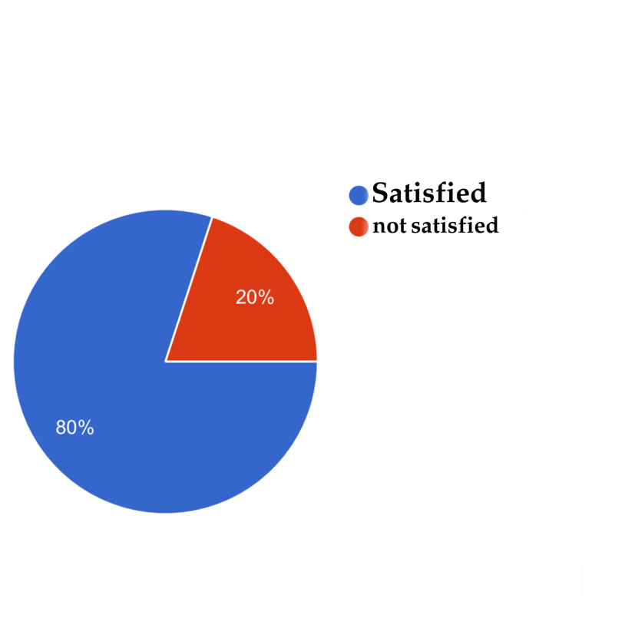

The teacher:

The system will allow teacher to create a group for students, set assignments for students and set a delivery date, mute the mic for any student, and remove the student from the group whenever he wants and make a live broadcast and include explanations during the live broadcast.

principal:

The system will allow the principal to monitoring the movements of teachers through the application, taking attendance and absence of teachers, registering new students.

## Non- Functional Requirement

Created by experts in the educational application industry, there is no room for error, they work to make everything perfect.

The system does not take long when booting, it only works from 1 to 3 seconds. The application gives the student the speed of joining classes, the application works on all devices, whether mobile phones or computers, and can be run from all search engines, the application receives the entry of one million students at the same time and this does not affect its efficiency. The application gives the student privacy by sending messages and privacy by knowing his marks, as no one else can see his marks .

Here we put for you a graph showing the extent to which users of the AZ students application are satisfied with the speed and privacy of the application.

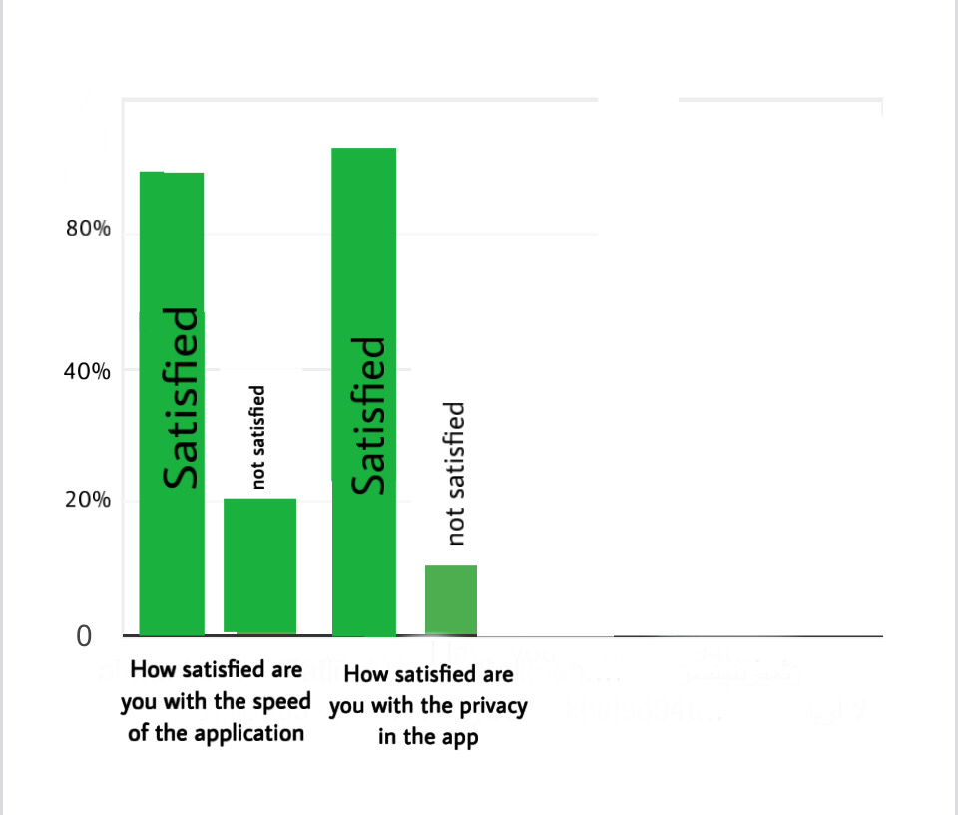

# FUNCTIONAL MODELS

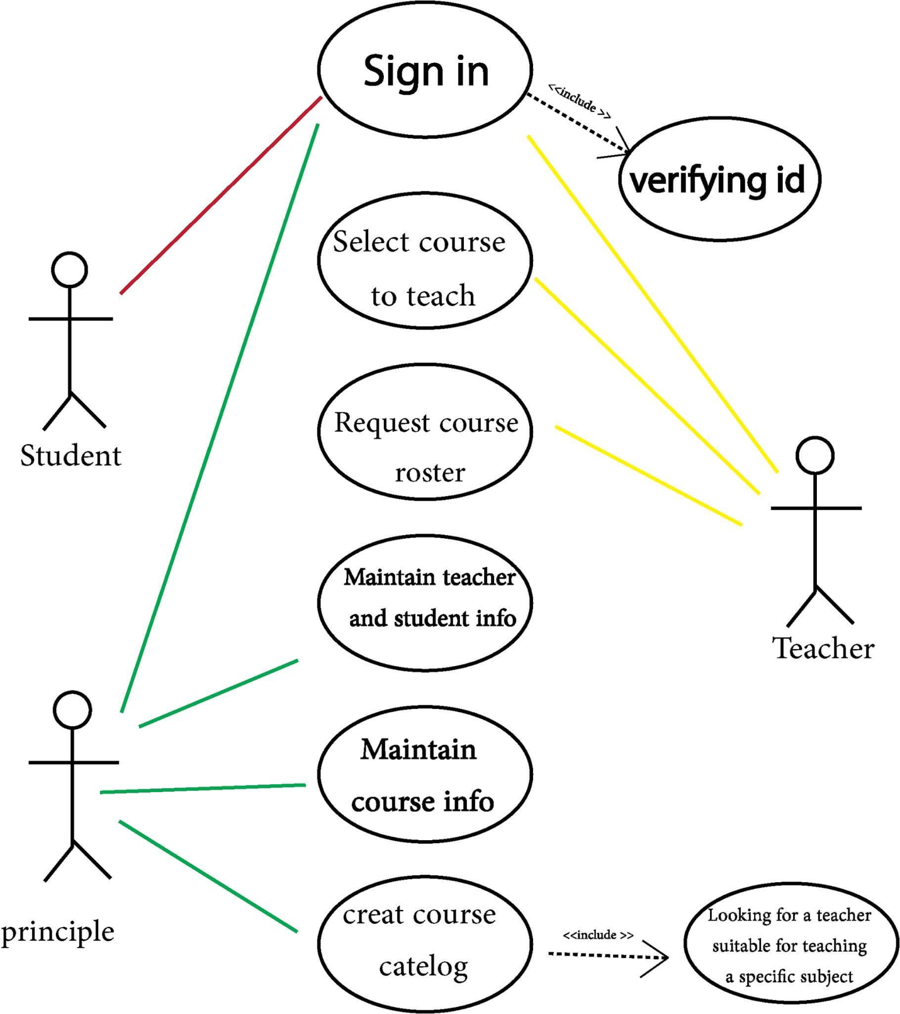

|  |  |
| --- | --- |
|  |  |
|  |  |
|  |  |
|  |  |
|  |  |
|  |  |
|  |  |
|  |  |
|  |  |
|  |  |
|  |  |
|  |  |
|  |  |
|  |  |
|  |  |
|  |  |
|  |  |

# STRUCTURAM MODELS

# BEHAVIORAL MODELS

# APPENDECIS

## <Appendix Name>